Write-Up Summary

Does average annual household income affect per capita opioid deaths?

We found a trend of lowering death over 7 years in the lowest income group, while conversely we found a trend of rising deaths over 7 years in the highest income group. We found that income had an effect on the amount of opioid deaths, this was determined to be significant due to the p-value found from the independent t-test.

What is the break down by opioid type (cause of death) for the lowest and highest income segments?

We found the high income areas are using more heroin year after year with little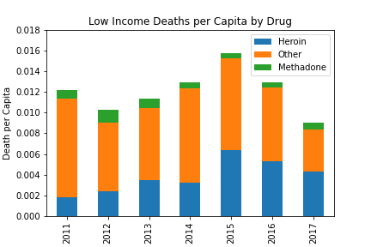 methadone use. While the lower income areas are a higher percentage of other drugs besides heroin.

What is the trend in opioid deaths among highest and lowest income segments by drug type?

The trend is low income areas in trending down even though there was a spike in 2015, 2017 had the lowest average of all seven years. While the trend for the high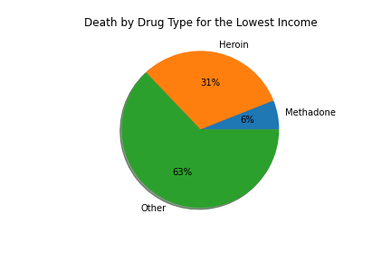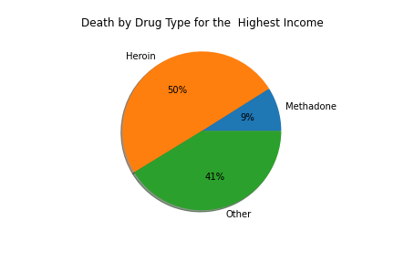 income areas in slowly moving upward each year.

What states of the country have the highest number of deaths (per capita)?

The top 4 states overall were West Virginia, Ohio, Kentucky, and New York. West Virginia started out really high but trended downward. Also Kentucky started pretty high and slowly trended downward all seven years. Although Ohio had a big jump from 2012 to 2015 it is now trending down. While New York slowly increased each year for all seven years.